SCHEDULE C – FORM OF PROPOSAL

RFP Project Title: Surrey Dog Off-Leash Area Strategy

RFP Reference No.: 1220-030-2023-035

Legal Name of Proponent:

Contact Person and Title:

Business Address:

Business Telephone:

Business Fax:

Business E-Mail Address:

TO:

City of Surrey

City Representative: Sunny Kaila, Manager, Procurement Services

E-mail for PDF Files: purchasing@surrey.ca

Dear Sir:

- I/We, the undersigned duly authorized representative of the Proponent, having received and carefully reviewed all of the Proposal documents, including the RFP and any issued addenda posted on the City Website and BC Bid Website, and having full knowledge of the Site, and having fully informed ourselves as to the intent, difficulties, facilities and local conditions attendant to performing the Services, submit this Proposal in response to the RFP.

- I/We confirm that the following schedules are attached to and form a part of this Proposal:

Schedule C-1 – Statement of Departures;
Schedule C-2 – Proponent’s Experience, Reputation and Resources;
Schedule C-3 – Proponent’s Technical Proposal (Services);
Schedule C-4 – Proponent's Technical Proposal (Time Schedule); and
Schedule C-5 – Proponent’s Financial Proposal.

3.0 I/We confirm that this proposal is accurate and true to best of my/our knowledge.

4.0 I/We confirm that, if I/we am/are awarded a contract, I/we will at all times be the “prime contractor” as provided by the Worker's Compensation Act (British Columbia) with respect to the Services. I/we further confirm that if I/we become aware that another consultant at the place(s) of the Services has been designated as the “prime contractor”, I/we will notify the City immediately, and I/we will indemnify and hold the City harmless against any claims, demands, losses, damages, costs, liabilities or expenses suffered by the City in connection with any failure to so notify the City.

This Proposal is submitted this [day] day of [month], [year].

I/We have the authority to bind the Proponent.

_______________________________________  (Legal Name of Proponent)  ________________________________________  (Signature of Authorized Signatory)  _______________________________________  (Print Name and Position of Authorized Signatory) | _____________________________________  (Signature of Authorized Signatory)  ______________________________________  (Print Name and Position of Authorized Signatory)

SCHEDULE C-1 - STATEMENT OF DEPARTURES

1. I/We have reviewed the proposed Contract attached to the RFP as Schedule “B”. If requested by the City, I/we would be prepared to enter into that Contract, amended by the following departures (list, if any):

Section Requested Departure(s) / Alternative(s)
______________________________________________________________________

______________________________________________________________________

2. The City of Surrey requires that the successful Proponent have the following in place before commencing the Services:
(a) Workers’ Compensation Board coverage in good standing and further, if an “Owner Operator” is involved, personal operator protection (P.O.P.) will be provided,
Workers' Compensation Registration Number ___________________________;
(b) Prime Contractor qualified coordinator is Name: _______________
and Contact Number: _________________________;
(c) Insurance coverage for the amounts required in the proposed agreement as a minimum, naming the City as additional insured and generally in compliance with the City’s sample insurance certificate form available on the City’s Website at www.surrey.ca search Consultants Certificate of Insurance;
(d) City of Surrey or Intermunicipal Business License: Number ________________;
(e) If the Consultant’s Services are subject to GST, the Consultant’s GST Number is _____________________________________; and
(f) If the Consultant is a company, the company name indicated above is registered with the Registrar of Companies in the Province of British Columbia, Canada, Incorporation Number ___________________________________.

As of the date of this Proposal, we advise that we have the ability to meet all of the above requirements except as follows (list, if any):

Section Requested Departure(s) / Alternative(s)
______________________________________________________________________

______________________________________________________________________

3. I/We offer the following alternates to improve the Services described in the RFP (list, if any):

Section Requested Departure(s) / Alternative(s)
______________________________________________________________________

______________________________________________________________________

4. The Proponent acknowledges that the departures it has requested in Sections 1, 2 and 3 of this Schedule C-1 will not form part of the Contract unless and until the City agrees to them in writing by initialling or otherwise specifically consenting in writing to be bound by any of them.

SCHEDULE C-2 - PROPONENT’S EXPERIENCE, REPUTATION AND RESOURCES

Proponents should provide information on the following (use the spaces provided and/or attach additional pages, if necessary):

- Location of primary business, branch locations, background, stability, structure of the Proponent and number of years business has been operational;

- Proponent’s relevant experience and qualifications in delivering services similar to those required by the RFP;

- Proponent’s demonstrated ability to provide the Services;

- Proponent’s equipment resources, capability and capacity, as relevant;

- Proponent’s references (name and telephone number). The City's preference is to have a minimum of three references;

- Proponent’s financial strength (with evidence such as financial statements, bank references);

- Describe any difficulties or challenges you might anticipate in providing the Services to the City and how you would plan to manage these;

- Describe the Proponent and its team’s demonstrated awareness and experience in preparing recommendations associated with defining the Dog Off-Leash Area Strategy;

- Proponents should provide information on the background and experience of all key personnel proposed to undertake the Services (use the spaces provided and/or attach additional pages, if necessary);

Key Personnel

Name:

Experience:

Dates:
Project Name:
Responsibility:

Dates:
Project Name:
Responsibility:

Project Approach – Team Roles

- Proponents should provide an outline of the resource roles and estimated effort required for this project. (use the spaces provided and/or attach additional pages, if necessary); and

Role | Name | Forecasted Project Days/Hrs.

Sub-Contractors

- Proponents should provide the following information on the background and experience of all sub-contractors proposed to undertake a portion of the Services (use the spaces provided and/or attach additional pages, if necessary).

DESCRIPTION OF SERVICES | SUB-CONTRACTORS NAME | YEARS OF WORKING WITH PROPONENT | TELEPHONE NUMBER AND EMAIL

[END OF PAGE]

SCHEDULE C-3 - PROPONENT’S TECHNICAL PROPOSAL (SERVICES)

Proponents should provide the following (use the spaces provided and/or attach additional pages, if necessary):

- a narrative that illustrates an understanding of the City’s requirements and Services;

- a description of the general approach and methodology that the Proponent would take in performing the Services including specifications and requirements;

- a narrative that illustrates how the Proponent will complete the scope of Services, manage the Services, and accomplish required objectives within the City’s schedule;

- a description of the work to be undertaken to complete the project’s requirements and deliverables as outlined in Schedule A;

- a description of the standards to be met by the Proponent in providing the Services;

- Work Plan: A description of work schedule with proposed start and completion dates, key milestones, and meetings with staff;

- list of reports that you would anticipate providing the City’s management team, including their relationship to project milestones and the method of delivery (electronic, paper, e-mail, other);

- sample documentation, if available, of experience that demonstrate an awareness of the following:
- Overall municipal park ‘system’ planning principles
- The diversity of public interest served by municipal parklands.
- The planning, design, and maintenance considerations for dog OLAs on Cty land.
- The financial considerations in planning, designing and maintaining dog OLAs.
- Equity-based principles in planning for public assets.
- Sustainable design and asset management; and

- Value Added Services: The Proponent should provide a description of value added, innovative ideas and unique services that the Proponent can offer to implement the City’s requirements relevant to the scope of Services described in this RFP. Unless otherwise stated, it is understood that there are no extra costs for these services.

[END OF PAGE]

SCHEDULE C-4 - PROPONENT’S TECHNICAL PROPOSAL (TIME SCHEDULE)

The City encourages responses that demonstrate a thorough understanding of the nature of the work and what the Proponent must do to get the work done properly. To this end, Proponents should provide an estimated project schedule, with major item descriptions and time indicating a commitment to perform the Services within the time specified (use the spaces provided and/or attach additional pages, if necessary).

ACTIVITY  (Insert Milestone Dates) | Time from Notice to Proceed in Days
 | 10 | 20 | 30 | 40 | 50 | 60 | 70 | 80 | 90 | 100
Letter of Intent
SAMPLE
Substantial Completion

SCHEDULE C-5 - PROPONENT’S FINANCIAL PROPOSAL

Proposal to include a budget for the project that includes consultant fees for the individual scope of work components, disbursements, and other soft costs. Include a table of consultants, expected number of hours per task, cost per hour for review, and provide totals for all hours and costs to sum up budget line items.

Schedule of Rates:

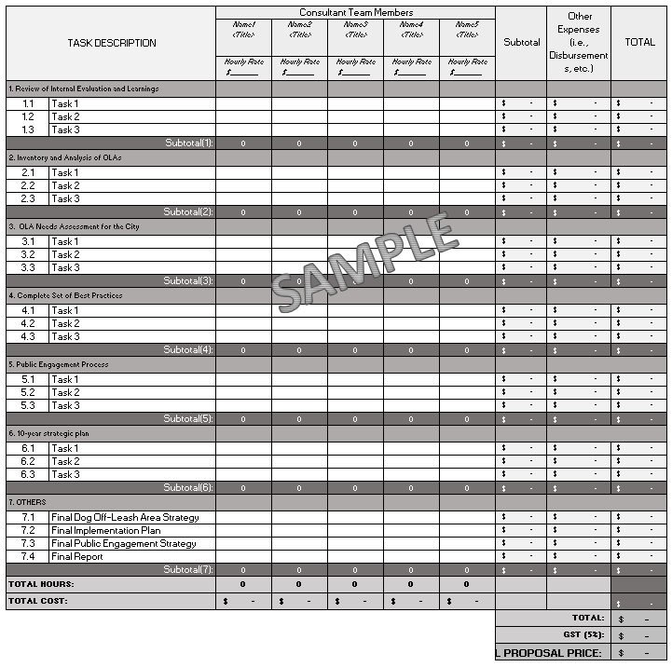

Additional Expenses:

The proposed Contract attached as Schedule "B" to the RFP provides that expenses are to be included within the fee, other than the expenses listed in the Contract as disbursements. Details of disbursements are to be shown in the chart above. Please indicate any expenses that would be payable in addition to the proposed fee and proposed disbursements set out above:

Payment Terms:

A cash discount of ______% will be allowed if account is paid within _______ days, or the _________ day of the month following, or net 30 days, on a best effort basis.

[END OF AGE]

